How to Use the State of Montana’s File Transfer Service https://transfer.mt.gov

PLEASE READ THIS WHOLE DOCUMENT TO UNDERSTAND HOW TO USE THE FILE TRANSFER SERVICE BEFORE CALLING FOR ASSISTANCE.
The State of Montana's File Transfer Service allows for easy transfer of large electronic files to and from customers of state government. It is designed to facilitate file exchange when files are too large for email. It also allows for secure transfer of sensitive data.
This service requires no software except for a web browser. All aspects of the transfer are securely encrypted, ensuring that customers meet all security requirements under state and federal information privacy regulations. Files are scanned for viruses during transfer.
An automated reminder system notifies the recipient of files they have available for download, and the system tracks receipts for all transfers, showing detailed information about when a file is uploaded as well as when it is downloaded.
Customers can upload files as large as 2GB. Files must be downloaded within fifteen days, after which the transfer expires and the files are automatically removed from the service.
A couple of additional things to note:
- The transfer of files must include a state email address either on the sending or receiving end.
- State employees are able to send files to other state employees or State of Montana customers/vendors.
- Outside customers/vendors are only able to send files to state employees.
- State of Montana employees, do not create an ePass Montana account, login as directed below using your c#. You will already have an account.
- If you are a customer/vendor doing business with the State of Montana and need to email large files to a state or numerous state employees, you must become a registered ePass customer by creating an ePass Montana account.
- Instructions on sending files through the file transfer service.

- Access the website by typing https://app.mt.gov/epass/Authn/selectIDP.html (this URL is easier than using transfer.mt.gov) in your web browser’s address line. How you log on will depend on if you have a State email address or not. If you do not have a State email address, go directly to Step 3 below.
1) If you have a State email account, click on the State Employee Login (right side) and log on with your State credentials. See screenshot below. Login, then proceed to B.
- If you are not a State Employee AND you already have an ePass account, click on the Login with ePass Montana (left side) button and use the credentials you established for your logon. See screenshot below. Login, then proceed to B)
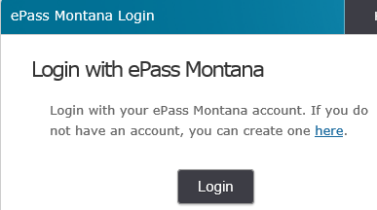
- If you do not have a State email address AND you do not have an ePass account, you must create one. Click in the red circle below to follow the link to create an account.
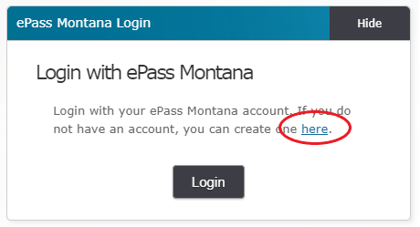

- Follow the instructions for creating an account on the next page and click save when you are done. It will look like this:
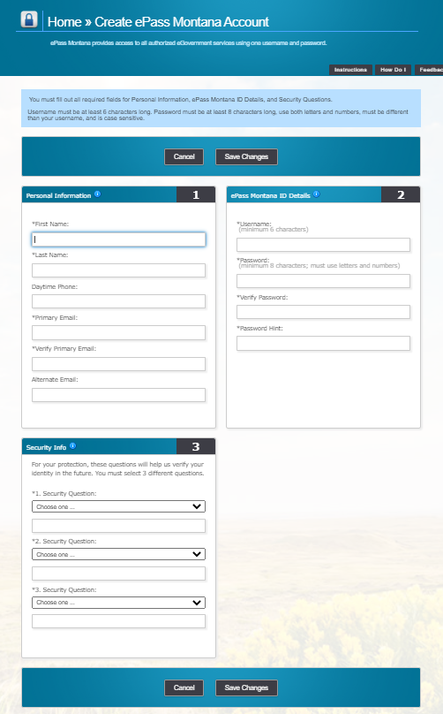
- If you are having issues creating an account, please call the DOJ ServiceDesk at 406-444-3993 for help or email them at DOJServiceDesk@mt.gov.
NOTE: If you are working with the CJIN or Livescan Bureau’s, please call them at 406-444-2800 for help or email them at DOJDCICJINServices@mt.gov.
- Once the logon process is completed. Proceed to step B) below.

- After logging in, click the File Transfer Service OR select the tab, “+Send a New File.”
- Click your mouse in the gray block with the words “Drop Files Here or Click to Upload.”
- Select the directory in which the scanned document(s) reside, then click the file you want to upload and then click “Open.” A grey line will appear by which you should be able to see the progress of the file as it uploads. Once the file is loaded, a green dot with a white check mark will appear to the right of the grey line.
- Click “Continue”.
- You should be presented with a screen named, “Recipient Options”. In the box titled, “General” click the box titled, “State Employee or ePass Montana Customer”. Then in the field that appears titled, “To:” type the email addresses shown below. They should be separated with a comma. Example: DOJSecurity@mt.gov, DOJEmployee@mt.gov
- Once the emails addresses are entered, click over into the box titled, “Message” and type a note. Then type your name, agency name, and your phone number.
- Then click the “Send” button.
- In the upper right-hand corner in the dark gray line is a somewhat-hard-to-see word, “Logout”. Click that word and you will be logged out of File Transfer Service.
- Close your browser when finished to delete any login credentials left in your computer’s memory.

