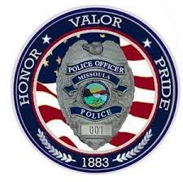
Hosted by the Missoula Police Department:
The Bullet Proof Mind:
Psychological Preparation for Combat
Registration Form
Name/Title:________________________
Dept:_____________________________
Address:___________________________
City/State/Zip:______________________
Phone:____________________________
Fax:______________________________
Email:____________________________
Check Which Time You Want to Attend:
- Full Day (8am-5pm)
- Half Day Morning (8am-12pm)
- Half Day Afternoon (1pm-5pm)
Registration Fee:
$250/Full Day
$125/Half Day
All registration fees must be received by
January 7, 2022

Send Payment to:
Missoula Police Department
435 Ryman Street, Missoula, MT 59802

For more information contact Training Officer Becky Potton at
406-552-6289 or
PottonB@ci.missoula.mt.us

Location: Hilton Garden Inn
3720 North Reserve St, Missoula MT 59808
1:00 pm to 5:00 pm
January 12, 2022
The Bullet Proof Mind
Mental Preparation
For Combat
Lt. Col. Dave Grossman

Police officers and soldiers know all about maintaining physical readiness for combat, but it is the mind that must first be properly prepared- the mind which controls the hands, arms, eyes, and ears.
From Lt. Col. Grossman, you’ll learn how the body responds to lethal combat, what happens to your blood flow, your muscles, your judgment, memory, vision, and hearing when someone is trying to kill you.
You’ll learn how to keep going even if you’re shot, and how to prepare your mind for survival instead of defeat.
Lt. Col. Dave Grossman’s training is not merely information – it is armor you’ll carry throughout your life.
- Gavin de Becker
8:00 am to 12 pm
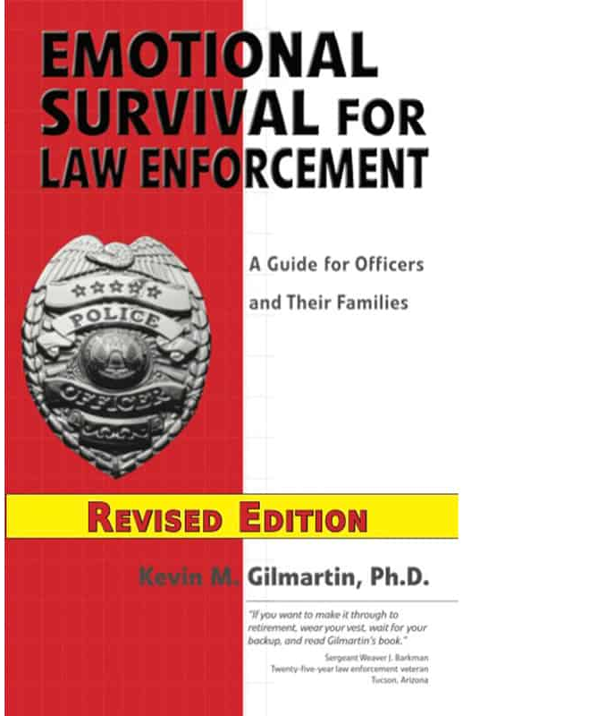
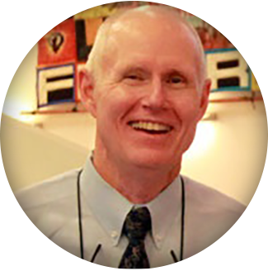
Emotional Survival for Law Enforcement - Consulting and Training by Kevin M. Gilmartin, Ph.D.
In Dr. Gilmartin’s presentation, you will review the short and long term effects on law enforcement officers on both the personal and professional aspect of their lives. The goal of the course is to have the law enforcement professional review the potential impact the career causes in the personal life and to develop strategies for overall emotional survival. The course is also to provide information that lets agencies keep officers committed and engaged in productive police work. The course is presented at all FBI LEEDS and Executive Development Institutes at the FBI Academy in Quantico, Virginia.

