PANDEMIC BUSINESS CONTINUITY PLANNING STRATEGY
This document describes a strategy for sustaining utility operations
in the event of an influenza pandemic, based upon previous world pandemic events. This strategy can be updated and applied to potentially pandemic situations. 36 Pages 47-494

We strive to continually update our Document Library for the benefit of our Members. Please consider contributing documents from your organization.
Thank you!

These documents have been voluntarily contributed by NOREX Members with the full knowledge that other Members may use them in any manner they see fit. NOREX and its Members shall not be held liable for any statements or interpretations contained within the documents.

Strategy

for

Pandemic

Business Continuity Planning

CONFIDENTIALITY STATEMENT
This document contains confidential and proprietary information and is the sole property of [ORG]. The document or its contents shall not be disclosed, distributed or copied without the written permission of [ORG].
TABLE OF CONTENTS
EXECUTIVE OVERVIEW 4
POLICY 5
OBJECTIVE 5
BACKGROUND 5
Introduction 5
Influenza Pandemic 5
Pandemic Characteristics 6
Current Situation 6
PLANNING ASSUMPTIONS 9
METHODOLOGY: Applying Six Sigma DMAIC to Business Continuity Planning 11
BUSINESS CONTINUITY TIMELINE 13
PROBLEM DEFINITION 16
MEASUREMENT AND ANALYSIS 17
Crisis Management Team 18
Business Unit Planning 19
Phase 1 – Alert 19
Phase 2 – Pre-Pandemic 20
Phase 3 – Pandemic Outbreak 20
Phase 4 – Maximum Disruption 21
Phase 5 – Prolonged Recovery 21
Testing the Plans 22
Table Top 22
Functional 22
PROCESS CONTROL 22
APPENDIX A - Ten things you need to know about pandemic influenza 24
APPENDIX B - NERC Key Planning Actions by Function 27
APPENDIX D - Considerations for business unit response plans and procedures 38

EXECUTIVE OVERVIEW

The following document describes (company)’s strategy for sustaining utility operations in the event of an influenza pandemic. An influenza pandemic is defined as a global outbreak when a virus new to humans is easily transmitted from person to person, resulting in serious illness and death. This document will be used to assist in evaluating the circumstances leading up to a pandemic, the company’s response plan to the pandemic and the recovery procedures in the wake of the pandemic.
This document may be segregated into three parts:
- Pandemic background information
- Strategy to develop pandemic business continuity plan
- Pandemic business continuity planning and preparation

The pandemic threat we are facing today is the possibility of an influenza pandemic caused by the H5N1 virus, which is currently infecting large populations of birds predominantly in Asia and Europe. The virus first surfaced in 1996 and has infected more than 220 people world-wide of which more than 120 have died. The virus has gained the attention of governments and medical organizations around the world. Historically, pandemic outbreaks occur several times per century. All outbreaks in the last century can be traced to an avian contaminant. Health experts believe it is not a matter of if a pandemic will occur, but when it will occur.
Traditional business continuity planning focuses on the loss of a physical facility or information technology infrastructure. Pandemic business continuity planning requires a different approach in that a pandemic impacts key resources such as human resources, facilities, supplies, information and capital. The human impact and duration of disruption are greater for a pandemic than for many other business disruptions. Society is dependent on the critical services of key infrastructure providers such as those in the energy, transportation and telecommunication sectors, which will be expected to maintain some level of operation during a pandemic.
In early 2006 senior management identified an influenza pandemic as a significant operational and reputational risk to (company). A team was organized to prepare an enterprise-wide business continuity plan to address this threat. Representatives from key areas of the company include gas and electric operations; generation, transmissions and power/gas supply; human resources; facilities; communications; supply chain; security; information technology; finance; and central support services. Departmental business continuity plans will be developed to address specific requirements and then integrated into the enterprise plan. Plan drafts are to be completed by 4th quarter 2006, with testing to commence by year-end.

POLICY
It is the policy of (company) to develop and maintain a business continuity plan that will provide the enterprise with every opportunity to withstand a catastrophic event. The goal is to provide advance planning for the disruption, to effectively manage through the disruption and to resume operations quickly and effectively. (company) also recognizes the need to establish comprehensive business continuity policies to protect employee health, life and safety.

OBJECTIVE
The purpose of a business continuity plan is to provide for an orderly, timely resumption of business operations by clearly defining roles and responsibilities as well as resources, equipment, supplies and documentation required to execute the plan. The objective of this document is to provide information about the global threat of an influenza pandemic, to describe (company)’a strategy for preparing for this threat, and to outline the actions required to mitigate the risk. A pandemic event could potentially impact (company)’s ability to sustain critical operations and to provide support for mission-critical services. Although many actions must yet be completed in order to mitigate this risk, (company) recognizes the need to plan for such an event in order to minimize the impact and to enhance the recovery process. Upon its completion the Pandemic Business Continuity Plan will include measures to address life-safety issues and will be used as a resource before, during and after a pandemic event.

BACKGROUND

Introduction
Traditionally, business continuity planning is focused on physical facility evacuation, loss of communications or loss of information technology infrastructure. The energy sector requires additional preparations for a greater range of threats that must be faced by owners and operators of the physical system. Such threats include adverse weather, vandalism, equipment failure, terrorism and even Y2K. The threat of a pandemic not only impacts the energy sector but every facet of society on a global scale.

Influenza Pandemic
The new threat we are facing today is the possibility of an influenza pandemic caused by the H5N1 virus. A pandemic is defined as a global outbreak when a new virus is able to be transmitted from human to human, resulting in serious illness and death worldwide. The H5N1 virus is currently infecting large populations of birds in Asia and has spread to migratory birds on the European continent. The virus has not only infected birds but humans as well, many times with fatal results. The H5N1 virus first surfaced in 1996. The virus is spreading rapidly in domesticated birds and birds in the wild. Studies of migratory birds in the North American continent are in progress but no cases have been reported in the North American continent to date.
The recent cases in humans and domesticated animals have contributed to the widespread awareness of the H5N1 virus. The virus has attracted serious attention by governments and medical organizations around the world. Health experts agree that it is not a matter of if a pandemic will occur, but when it will occur. The timing and impact will depend on many factors which are difficult to predict because the global situation is ever changing. We do know from history that influenza pandemic outbreaks have occurred several times in the past century. The Spanish flu of 1918 originated from an avian contaminant and killed approximately 50 million people. The outbreaks in 1957 and 1968 as well as the SARS outbreak in 2003 all originated from an avian flu. Given the mobile society in which we live today, experts agree that the number of dead as a result of the H5N1 virus could be as high as 200 million people. Consider the effect of such an outbreak on the utility sector’s ability to provide essential services. The utility sector’s business continuity plans need to address this risk.

Pandemic Characteristics
The threat of an influenza pandemic presents a different challenge than most business continuity planning initiatives, which are typically focused on disasters. Disasters usually have very little warning, are a one-time occurrence, and affect a limited geographic area. Pandemics on the other hand, are monitored for an extended period of time before an actual outbreak, occur over an extended period of time and have a widespread impact on global society and economic conditions. The unique characteristics of a pandemic can be summarized as follows:
- Worldwide Impact: Unlike most threats that are localized to a particular region, a pandemic has the potential for global impact. From a utility perspective it could affect operations simultaneously across North America and around the world. Supply availability and employee availability and ability to provide services would be greatly impacted.
- Duration: An influenza pandemic could severely disrupt operations for six to eight weeks if not longer. Subsequent waves of the virus could resurface in 3-6 months after the initial outbreak, causing more illnesses and deaths than the first. Some level of fear would spread through the population prior to the actual outbreak. Depending on the attack rate among the local population the impact to absenteeism from work could range from 1-3 weeks for an individual.
- Mortality: Based on current estimates the projections for mortality range anywhere from .5 percent to 2 percent worldwide. Even a low end mortality rate would cause severe disruption for employees suffering the loss of family, friends and coworkers. Business continuity plans need to recognize and address the anxiety levels employees will experience during a pandemic by providing empathy and support. Cross training and knowledge transfer are critical to sustaining operations and services.

Current Situation
The H5N1 virus is an especially dangerous strain and closely resembles the 1918 Spanish flu strain which caused an estimated 50 million deaths worldwide. The 1918 pandemic had rates of infection for the entire population of up to 32 percent. Over just the last two years fatal human cases of the H5N1 virus have occurred in Asia, Turkey, Iraq, and Egypt. Of late the situation in Indonesia is being monitored closely due to multiple infections within members of an extended family. The virus has been found in migratory birds across Europe and Australia. As with the 1918 strain, the H5N1 virus originated in birds and has been found to be transmitted from birds to animals and humans. Today there is no evidence that the virus has been transmitted from human to human. Health officials believe it is only a matter of time before the virus mutates to a form that is readily transferable among humans, although they do not know exactly when this will happen. Based on reports from the World Health Organization, as of June 1, 2006 a total of 224 people have been reported to be infected with the virus with 127 of these cases resulting in death. The human mortality rate particularly in Asia for those infected has been well over 50 percent.
No vaccine has been developed yet for the H5N1 strain, which is expected to be virulent. A vaccine cannot be developed until the virus mutates into a human to human strain. Realistically, timely production will not be possible for the number of inoculations needed to provide widespread protection to society. The antiviral drug Tamiflu may be effective against the virus but the drug is in very short supply around the world. The Unites States government has drafted a plan to indicate the priority of recipients of the antiviral medication as it becomes available. Issues faced with anti-viral medicines include availability, effectiveness against specific virus strains and dosage levels for pre-infection prevention as compared to post-infection treatment. Research studies have shown that the virus is not easily transmittable by coughing and sneezing like other seasonal flu viruses. Most human flu viruses attach themselves to cells in the nose and throat. By contrast in most infected patients the H5N1 strain has been found to attach to cells in the lower respiratory tract with the rapid development of pneumonia leading to death.
Heightened global awareness has led to predictions that if human-to-human transmission occurs, a human breakout of the H5N1 virus could spread from Asia around the world in a matter of three to eight weeks because of today’s mobile society. Estimates indicate that as many as 25 percent of the general population would be infected. The pandemic is expected to occur in 2-3 waves occurring 3-6 months apart, with each subsequent wave being stronger than the preceding wave. It is believed that those infected in an earlier wave would not be infected in subsequent waves, as long as the virus does continue to mutate into another strain.
SEVERITY PHASES

Much of the information available today about the influenza pandemic has been developed by the World Health Organization (WHO) and the Center for Disease Control (CDC). WHO has designated six phases of pandemic progression and severity. The North American Electric Reliability Council (NERC) has adjusted the designations for use in the electricity and natural gas sectors. (company)’s pandemic business continuity planning efforts are aligned with the NERC recommendations. The table below shows the relationship between the NERC and WHO phases and the general business consequences of each phase. Currently we are in the NERC Pre-Pandemic Phase 2 where no human-to-human transmission is thought to have occurred. The time to plan for pandemic business continuity is now.
NERC Phase | WHO/CDC Phase | Consequences for Businesses
1  Pandemic Alert | 1 – low risk of human cases  2 – higher risk of human cases | Governments, owners, and operators are notified a pandemic is possible and preparedness plans should be reviewed and updated.
2  Pre-Pandemic | 3 – no or limited human-to-human transmission | Governments and electricity and natural gas sectors begin to assign resources, prepare staffing, and implement contingency plans. Begin an information distribution program to promote appropriate responses by employees.
3  Pandemic  Outbreak | 4 – evidence of increased human-to-human transmission | General outbreaks across borders and continents. Implement response plans.
4  Maximum  Disruption | 5 – evidence of significant human-to-human transmission  6 – efficient and sustained human-to-human transmission | High absentee rates would occur (35 percent) and fatalities would begin to impact the workforce. This phase could last for several months.
5  Prolonged  Recovery |  | Recovery will be slow and the underlying economy will weaken. Altered business conditions will be prevalent for large and small firms. This phase will last for at least three months and possibly up to six months.

PLANNING ASSUMPTIONS

During a pandemic it will be critical for key infrastructure providers such those in the electric and natural gas sectors to maintain some level of operation. The same would apply to other public support sectors such water and telecommunication providers, railroads, transportation providers, fuel pipelines, and financial institutions. Note that financial markets did not close down during the recent catastrophe in the gulf with hurricane Katrina. The following are the assumptions (company) is using for scenario planning for pandemic business continuity preparations.
- A cornerstone of (company)’s pandemic business continuity plan is the assumption that the public and financial sectors have developed or are in the process of developing their own business continuity plans for a pandemic event. Interdependencies with other utility segments, critical infrastructure providers, contractors and suppliers will be severely tested during a pandemic.

- The highest priority of an electric or gas utility during a pandemic is the physical production and delivery of the energy. Metering, billing, collection, timely financial reporting and regulatory compliance would be secondary considerations. Many essential services would likely have to operate in this mode. The risk with this type of prioritization is the possibility of debt covenant breaches and the resultant cross-defaults. Consequently, there will likely be some form of governmental involvement. This leads to the second key assumption: access to government-backed loan guarantees and temporary waivers of legal and regulatory requirements. (company) will seek waivers including but not limited to financial reporting, environmental compliance and reporting, regulatory compliance and debt covenants.

- It will be essential to provide access to accurate and timely information for employees, customers, shareholders, labor organizations and government before, during and after the pandemic.

- The timing of the outbreak of a pandemic is uncertain and is dependent on many factors that continue to emerge over time.

- Once human-to-human transmission begins, the disease will spread around the world within three to eight weeks.

- The attack rate for the general population is expected to be in the range of 25 percent and these people would be very ill for up to ten days.

- Absenteeism is expected to be 40-50% over a six to eight week time period, where the average person is unable or unwilling to work for up to three weeks for the duration of the pandemic. Absentee rates will not be uniform across the organization and will be due to personal illness, caring for sick family members, lack of transportation to get to work, and fear to come to work.

- A pandemic will strike in at least two waves, each lasting six to eight weeks. The first wave will peak in three to four weeks. The second wave will be three to six months after the first and will likely be stronger than the first. There may also be a third wave with characteristics similar to the second. Persons who contract the virus are not expected to contract it a second time due to a buildup of immunity. However, if the virus mutates, recurrences for the same individual may be possible.

- No vaccines or anti-viral medications will be available to employees in the first wave but limited quantities may be available for critical staff in time for the second wave.

- Human loss will be significant, with the mortality rate estimated at 50% for those infected.

- Personnel will need to be managed differently to conduct essential business processes and to minimize the spread of the virus.

- Current provisions in the union contracts are adequate, no further negotiations are required

- For testing purposes, the initial hot spot for (company) will occur in the (location) metro area and will include Headquarters, (location) and the (location) plant. Within a few weeks the outbreak will extend to (location), (location) and (location). Resources cannot be shared between (location) metro and other service territories, based on the expectation that quarantines will be imposed by the government.

- No major storms occur in the (location) metro area, (location), (location) or (location) during the six to eight week outbreak periods.

METHODOLOGY: Applying Six Sigma DMAIC to Business Continuity Planning
(Company)’s approach to pandemic business continuity planning is atypical of most business continuity planning efforts. In 20-- (company) embraced the Six Sigma methodology for business process improvements relative to cost saving efficiencies and effective customer service. High level process maps developed in the early Six Sigma stages at (company) were instrumental in identifying key business processes in the company. Utilizing the results of this analysis, the project team is driving out process weaknesses to prepare for a pandemic event. Only pockets of business continuity plans exist today. Some plans are up to date and well maintained, some are complete but untested and others are still in the development stage. None of these plans currently address pandemic business continuity planning. The Six Sigma methodology was chosen for pandemic planning because of the unique nature of a pandemic event and the tool’s ability to provide a fresh perspective on business process issues, stimulating project team participants to ‘think outside the box’. The methodology consists of five basic steps referred to as DMAIC:
D - Problem definition
M - Data measurement
A - Root cause analysis
I - Process improvements
C - Process control
The table on the following page provides a high-level description of each of the steps as well as the associated major tasks and deliverables.

Control Plan Identify key processes and resources and their control points.
Control
Monitor improvements to ensure desired effect was achieved.
Implementation Plan Include time line for action item resolution (phased implementation) as well as testing plans.
Improve
Implement improvements to address important root causes. Train users.
GAP Analysis Analyze gaps from failure modes.
Action Plan Prepared as a result of Gap analysis.
Analyze
Analyze key measurements, determine root causes. Determine where to focus improvements.
Research AGA, EEI, DR knowledge
Quantify Who, What, How Many. Where are the key personnel and critical departments. How to gain access.
Measure
Measure the current performance of the process.
SIPOC Identify Suppliers, Inputs, Process, Outputs, Customers
C&E Rank impact of critical processes against key resources
FMEA Identify risk associated with failures. Identify gaps.
Define
Define problem and scope. Determine customer and stakeholder requirements.

BUSINESS CONTINUITY TIMELINE

In March of 20-- the Leadership Team identified influenza pandemic as a significant operational and reputational risk to (company). In early April a pandemic steering team was identified and the project was initiated. A core team was established with participation from key business areas. The steering team and project sponsor provided a framework around critical processes and critical resources need to sustain business operations. The core team conducted a business impact analysis for their respective areas, referencing the high level process maps developed in (company)’s early Six Sigma discussions. Within a relatively short timeframe the core team identified the significant areas of risk and brainstormed about recommended actions to mitigate the risk. Following these discussions a draft of the project tasks, timelines and deliverables was developed. Process improvements relative to these tasks are planned for completion and testing in 20--. A graphical view of the timeline is shown on the following page.

Milestone
High level, critical processes defined;
Key resources needed to conduct business identified

Apr 1
Jun 1
Dec 1
Aug 1
May 1
Jul 1
Sep 1
Oct 1
Nov 1
Project Initiation:
Charter drafted
CTS (Critical to Success Factors)
Black Belt project manager identified
Core team assigned
Define Phase:
Risks identified
Milestone
Pandemic business continuity strategy drafted, business unit planning begins
Measure Phase:
Research
Quantify
Milestone
Integrated testing begins

Control Phase:
Develop Control Plan
Implement Controls
Implementation Phase:
Quick hits (6 weeks)
Mid-range (2-3 months)
Long-term (4-6 months)
Analyze Phase:
Gap analysis
Action Plan
Milestone
Business unit testing begins
Mar 1
Steering Team:
Problem Definition

PROBLEM DEFINITION

A corporate focus on business continuity planning and recent developments in Asia regarding influenza pandemic contributed to (company)’s decision to mitigate its risk for this threat. A pandemic steering team was put in place and a project charter was drafted. A Six Sigma Black Belt was assigned to manage the project and a core team was selected by the steering team with participation from the following business units:
- Human Resources
- Communications
- Finance
- Information Technology
- Central Services
- Operations
- Power Generation
- Supply Chain
- Security
- Facilities
- Internal Audit

The project sponsor and steering team provided the ‘Critical to Success Factors’ for operating the business as well as the resources required to conduct business. The core team members completed a SIPOC exercise to identify inputs, outputs, suppliers and customers for all processes in their business unit. They also completed a Business Impact Analysis for the key processes to identify the greatest financial and qualitative risks. Using the Cause & Effect Matrix, the resources were then ranked against the high level processes to drive out the areas of greatest risk across the enterprise. The operational areas of the business for the physical production and delivery of energy proved to be the areas of greatest risk. The Failure Modes & Effects Analysis tool was then used to identify the methods the processes could fail and to brainstorm about recommended action plans.

MEASUREMENT AND ANALYSIS

A multitude of research material is available on the Internet about influenza pandemic history, progression and response plans by international, government and health related organizations. Lessons learned from the SARS outbreak in 2003 were also helpful in planning a framework for mitigation. In order to benchmark (company)’s preparation against other utilities in the energy sectors, the American Gas Association (AGA) and Edison Electric Institute (EEI) were contacted to conduct surveys about the pandemic preparedness in the energy sector. The AGA does not have any information at this point about the number of oil and gas utilities who have developed plans or are in the process of developing plans. EEI conducted a survey of electric utilities and compiled this information. Of the eleven electric utilities that responded, five companies are in the process of developing pandemic business continuity plans and only 2 have completed their plans. The remaining six respondents indicated that either their company had not started planning for a pandemic event or they were not aware of their company’s progress in this regard. Another survey conducted by Mercer in the spring of 2006 indicates that 47% of corporations around the world have a business continuity plan in place for influenza pandemic. SARS affected countries seem to be further ahead with planning for the pandemic than non-SARS affected countries, which may indicate that influenza pandemic is considered to be an Asian problem.

Analysis of root cause problems with a pandemic event specific to (company) was approached as a joint effort among the core team. Upon review of various research material the team analyzed failure points of the key processes and identified action items to remedy the issues. The action items were assigned to a business unit for remediation. The business unit was asked to provide accountability, prioritization, and timeline for remediation. The action plan has three distinct timelines for implementation:

- Quick hits to be accomplished in a 6-8 week time period
- Short term deliverables to be completed with 2-3 months
- Long term deliverables to be completed in 4-6 months

Business unit business continuity plans are a key deliverable for most areas. These plans are a requirement for any business continuity planning. For those areas that already have a plan, another scenario will be added to the plan for a pandemic event. For those areas that do not have a plan, considerable effort will be required to produce a plan. The following areas have business continuity plans completed or in progress:

- Call Center
- Central Monitoring Station
- Field Resource Center - (location)
- Field Resource Center - (location)
- Gas Supply Services
- (location) Operations
- Generation Desk
- Human Resources
- Information Technology
- Investor Relations
- (location) Operations
- (location) Operations
- (location) Emergency Action Plan
- (location) Operations
- (location) Operations
- (location) Service Center

PROCESS IMPROVEMENT

Crisis Management Team
The Crisis Management Team (CMT) is an integral part of the pandemic business continuity planning strategy. The Leadership Team is responsible for appointing members to the CMT. (company) currently has a Crisis Management Plan which should be updated to include a pandemic event and membership to this team should be revisited. At least two alternates should be designated for each member. Although members will be responsible for recommendations and advice in his or her specialized field, the CMT will be responsible as a whole for all team decisions.
Responsibilities of the CMT include but are not limited to:
- Monitoring the status of current events and crisis that impact (company) operations, employees and facilities
- Make decisions in response to a crisis
- Liaise with senior management
- Declares a state of emergency
- Activates emergency action plan and establishes contact with business unit crisis teams
- Ensure timely and accurate communication to employees
- Controls the content, timing and method of delivery for all news media statements
- Ensures compliance with insurance requirements including coverage to obtain reimbursement of funds disbursed during a crisis
- Establish contact with appropriate governmental and health agencies
- Establish emergency and law enforcement contact lists
- Compile and maintain comprehensive contact information for all CMT members
- Ensures the maintenance of payroll and benefits during a crisis
- Develops plans to meet the needs employees and their families during a crisis
- Determines the financial consequences of a crisis
- Ensures the availability of funds to meet contingencies
- Examines the legal consequences of a crisis and determines corporate legal responsibilities
- Ensures that all decisions and actions taken by the CMT are in compliance with federal, state and local laws

Each business unit will designate a business continuity coordinator and crisis team for their specific area. At least two alternates should be named for each team member. The business unit coordinator will be responsible for overseeing the business continuity plan in their area.

Leadership Team
Crisis Management Team
(CMT)
Business
Unit
Crisis Teams
Business Unit
Crisis Teams
Business Unit
Crisis Teams
Business Unit
Crisis Teams

Business Unit Planning
(company)’s pandemic preparedness planning efforts are based primarily on the NERC framework for a phased response plan. Each business unit’s continuity plan will be prepared around the five-phase approach. The high level considerations by phase are noted below. The business units’ detailed action items to support these considerations and the associated priority and timeline may be found in Appendix D.

Phase 1 – Alert
- Monitor health information for threats
- Liaise with senior management
- Provide regular communication to employees on the latest health advisories and recommend adherence to all suggestions
- Provide regular communication to employees on any other pandemic specific information
- Provide employees with information about the contagion
  - Methods and ease of transmission
  - Time the contagion remains active
  - Incubation period, time for exhibiting symptoms and maximum contagious period
  - Personal and family protection and response suggestions and information on at-home care of the ill
- Identify critical functions and key personnel; pre-screen staff for vaccine and antiviral medications
- Communicate regularly with employees about health habits to minimize infections
- Initiate business continuity planning
- Develop response plans and procedures for critical business units
  - Consider the need to separate the work force to preserve a “clean” site
  - Consider teleconferencing and videoconferencing to limit human-to-human contact
  - Consider security issues and law enforcement limitations during an outbreak
  - Consider developing joint operational plans with service providers, suppliers and customers
  - Evaluate potential financial impact of interrupted operations, reduced revenue and interrupted supplies
  - Evaluate potential insurance cost increases due to medical costs
- Consider the need to send home non-critical staff
- Develop / update the travel policy
- Develop / update a policy for meetings
- Develop / update a visitor sign-in policy
- Consult with health authorities to update confidentiality policies to manage staff exposed to the contagion
- Develop / update a telecommunications policy
- Develop / update policy for compensation and sick leave unique to a pandemic

Phase 2 – Pre-Pandemic
- Monitor health information for threats (Crisis Management Team or HR?)
- Liaise with senior management
- Seek government-backed load guarantees and temporary waivers of regulatory, financial and environmental requirements
- Provide regular communication to employees on the latest health advisories and recommend adherence to all suggestions
- Provide regular communication to employees on any other pandemic specific information
- Provide employees with information about the contagion
- Communicate regularly with employees about health habits to minimize infections
- Encourage employees to prepare family readiness plans
- Advise employees that antibacterial hand cleanser will be placed at all communal areas
- Work with local health officials on the count of antiviral recipients for critical functions
- Develop / update workforce policies for teams and crews working together or in group, given the potential need to keep employees separated
- Periodically test and verify business unit plans and procedures
- Test the IT infrastructure’s capability to support increased telecommuting, teleconferencing and video conferencing
- Contract with a cleaning service to disinfect workstations, common areas and shared equipment
- Provide each workstation with a disinfectant spray, paper towels and latex gloves
- Determine what person protective equipment will be effective and acquire sufficient quantities early
- Provide critical operations staff with an ample supply of personal protective equipment
- For the cafeterias, stock up on water, beverages and non-perishable foods

Phase 3 – Pandemic Outbreak
- Monitor health information for threats (Crisis Management Team or HR?)
- Liaise with senior management
- Provide regular communication to employees on the latest health advisories and recommend adherence to all suggestions
- Provide regular communication to employees on any other pandemic specific information
- Emergency Action Center is activated
- Provide employees with information about the contagion
- Communicate regularly with employees about health habits to minimize infections
- Employees are to seek medical attention and advise the supervisor if virus is contracted or if exposed to the virus
- Company response plan is activated when an outbreak occurs
  - Advise exposed or infected employees to consult with their doctor and to notify their supervisor
  - Advise exposed or infected employees not to return to work until directed to do so, and to follow all policies in place
  - Supervisor contacts company medical coordinator to follow up on the employee
  - Ensure that on-site critical operations staff have adequate personal protective equipment
  - Implement a screening process for employees and visitors at critical facilities to identify potential risk
  - If appropriate, request the cleaning service to disinfect an affected employee’s workstation and all share work areas, equipment and facilities
  - Assess the need for staff to maintain an appropriate distance from others
  - Assess the need for separation or isolation of staff
  - Assess the need to vacate non-critical staff from the site
  - Close non-critical common areas including cafeterias
  - Consider the need and conditions for more extreme measures such as sequestering; provide accommodations as needed
  - Provide each workstation with a disinfectant spray, paper towels and latex gloves. Provide instructions for sanitization of the work area and shared equipment before and after use.
  - Provide regular communication to employees about the latest medical advisories and recommend adherence to suggested actions
  - If appropriate, isolate the building and suspend electronic card access. Notify staff on site to leave their name and all potential contact numbers. Instruct all employees when they will be allowed to return to work. Instruct visitors to provide their company and potential contact numbers.
  - Request employees to keep supervisors informed of their condition.

Phase 4 – Maximum Disruption
- Monitor health information for threats (Crisis Management Team or HR?)
- Liaise with senior management
- Sustain action plan from Phase 3
- Provide regular communication to employees on the latest health advisories and recommend adherence to all suggestions
- Provide regular communication to employees on any other pandemic specific information
- Communicate regularly with employees about health habits to minimize infections
- If appropriate, isolate the building and restrict access to critical staff only
- Request employees to keep supervisors informed of their condition.

Phase 5 – Prolonged Recovery
- Monitor health information for threats (Crisis Management Team or HR?)
- Liaise with senior management
- Provide regular communication to employees on the latest health advisories and recommend adherence to all suggestions
- Provide regular communication to employees on any other pandemic specific information
- Communicate regularly with employees about health habits to minimize infections
- If appropriate, lift restrictions on access to the buildings
- Request employees to keep supervisors informed of their condition.
- Company medical coordinator advises local health authorities of employee infections and deaths
- Employee support teams are deployed
- Inventories and resources are re-established
- Review lessons learned and implement appropriate changes in the business continuity plan

Testing the Plans
A plan is not a plan until testing has been completed. Testing can be as simple or complicated as necessary to ensure the plan is a viable tool to mitigate risk. Two types of testing are recommended for each business unit’s business continuity plan:

Table Top
A table-top exercise simulates an emergency situation in an informal stress-free environment. The participants meet to discuss general problems and procedures in the context of an emergency scenario. The focus is on training and familiarization with roles, responsibilities and procedures. The exercise requires minimal commitment of time, cost and resources. This is a good way to acquaint key personnel with their unit’s emergency responsibilities and procedures.

Functional
The functional exercise simulates an emergency in a more realistic manner. The goal is of this exercise is to test or evaluate the capability of one or more functions in the context of an emergency event. Players practice their response to an emergency by responding in a realistic way to carefully planned and sequenced messages given to them by simulators. All decisions and actions by players occur in real time and generate real responses and consequences from other players. The guiding principle is to mimic reality. The atmosphere is stressful because of the real-time actions and the unplanned problems that typically arise. This exercise tests many of the functions as with a full scale test but without the inherent costs. The process is often lengthy and requires careful scripting and planning.
An integrated functional test across all business units will be coordinated following the completion of the business unit plans.

PROCESS CONTROL

Once the process improvements are implemented, the last step in the Six Sigma approach will be to manage the changes by implementing controls around the processes. If this step is not completed the processes runs the risk of developing defects that go unnoticed. When the improvements are completed the plan is handed off to a process owner who is then responsible for ensuring that the plan is followed and managed. The intent is for the plan to be refreshed periodically with new developments about the pandemic and adjustments to the business continuity plans as required. The process owner will be responsible for:
- Contacting business unit process owners about the recent developments
- Ensuring that appropriate modifications are made to the business areas plans
- Ensuring that the plans are tested
- Verifying that the overall plan is tested
- Ensuring that employees are advised accordingly
- Providing communications to the appropriate state, federal, regulatory, environmental, financial and health agencies as pandemic developments progress.

APPENDIX A - Ten things you need to know about pandemic influenza

Source: The World Health Organization http://www.who.int/csr/disease/influenza/pandemic10things/en/index.html

14 October 2005
1. Pandemic influenza is different from avian influenza.
Avian influenza refers to a large group of different influenza viruses that primarily affect birds. On rare occasions, these bird viruses can infect other species, including pigs and humans. The vast majority of avian influenza viruses do not infect humans. An influenza pandemic happens when a new subtype emerges that has not previously circulated in humans.
For this reason, avian H5N1 is a strain with pandemic potential, since it might ultimately adapt into a strain that is contagious among humans. Once this adaptation occurs, it will no longer be a bird virus--it will be a human influenza virus. Influenza pandemics are caused by new influenza viruses that have adapted to humans.
2. Influenza pandemics are recurring events.
An influenza pandemic is a rare but recurrent event. Three pandemics occurred in the previous century: “Spanish influenza” in 1918, “Asian influenza” in 1957, and “Hong Kong influenza” in 1968. The 1918 pandemic killed an estimated 40–50 million people worldwide. That pandemic, which was exceptional, is considered one of the deadliest disease events in human history. Subsequent pandemics were much milder, with an estimated 2 million deaths in 1957 and 1 million deaths in 1968.
A pandemic occurs when a new influenza virus emerges and starts spreading as easily as 10 normal influenza – by coughing and sneezing. Because the virus is new, the human immune system will have no pre-existing immunity. This makes it likely that people who contract pandemic influenza will experience more serious disease than that caused by normal influenza.
3. The world may be on the brink of another pandemic.
Health experts have been monitoring a new and extremely severe influenza virus – the H5N1 strain – for almost eight years. The H5N1 strain first infected humans in Hong Kong in 1997, causing 18 cases, including six deaths. Since mid-2003, this virus has caused the largest and most severe outbreaks in poultry on record. In December 2003, infections in people exposed to sick birds were identified.
Since then, over 100 human cases have been laboratory confirmed in four Asian countries (Cambodia, Indonesia, Thailand, and Viet Nam), and more than half of these people have died. Most cases have occurred in previously healthy children and young adults. Fortunately, the virus does not jump easily from birds to humans or spread readily and sustainably among humans. Should H5N1 evolve to a form as contagious as normal influenza, a pandemic could begin.
4. All countries will be affected.
Once a fully contagious virus emerges, its global spread is considered inevitable. Countries might, through measures such as border closures and travel restrictions, delay arrival of the virus, but cannot stop it. The pandemics of the previous century encircled the globe in 6 to 9 months, even when most international travel was by ship. Given the speed and volume of international air travel today, the virus could spread more rapidly, possibly reaching all continents in less than 3 months.
5. Widespread illness will occur.
Because most people will have no immunity to the pandemic virus, infection and illness rates are expected to be higher than during seasonal epidemics of normal influenza. Current projections for the next pandemic estimate that a substantial percentage of the world’s population will require some form of medical care. Few countries have the staff, facilities, equipment, and hospital beds needed to cope with large numbers of people who suddenly fall ill.
6. Medical supplies will be inadequate.
Supplies of vaccines and antiviral drugs – the two most important medical interventions for reducing illness and deaths during a pandemic – will be inadequate in all countries at the start of a pandemic and for many months thereafter. Inadequate supplies of vaccines are of particular concern, as vaccines are considered the first line of defense for protecting populations. On present trends, many developing countries will have no access to vaccines throughout the duration of a pandemic.
7. Large numbers of deaths will occur.
Historically, the number of deaths during a pandemic has varied greatly. Death rates are largely determined by four factors: the number of people who become infected, the virulence of the virus, the underlying characteristics and vulnerability of affected populations, and the effectiveness of preventive measures. Accurate predictions of mortality cannot be made before the pandemic virus emerges and begins to spread. All estimates of the number of deaths are purely speculative.
WHO has used a relatively conservative estimate – from 2 million to 7.4 million deaths – because it provides a useful and plausible planning target. This estimate is based on the comparatively mild 1957 pandemic. Estimates based on a more virulent virus, closer to the one seen in 1918, have been made and are much higher. However, the 1918 pandemic was considered exceptional.
8. Economic and social disruption will be great.
High rates of illness and worker absenteeism are expected, and these will contribute to social and economic disruption. Past pandemics have spread globally in two and sometimes three waves. Not all parts of the world or of a single country are expected to be severely affected at the same time. Social and economic disruptions could be temporary, but may be amplified in today’s closely interrelated and interdependent systems of trade and commerce. Social disruption may be greatest when rates of absenteeism impair essential services, such as power, transportation, and communications.
9. Every country must be prepared.
WHO has issued a series of recommended strategic actions UPDATED LINK (https://www.who.int/emergencies/diseases/novel-coronavirus-2019) for responding to the influenza pandemic threat. The actions are designed to provide different layers of defense that reflect the complexity of the evolving situation. Recommended actions are different for the present phase of pandemic alert, the emergence of a pandemic virus, and the declaration of a pandemic and its subsequent international spread.
10. WHO will alert the world when the pandemic threat increases.
WHO works closely with ministries of health and various public health organizations to support countries' surveillance of circulating influenza strains. A sensitive surveillance system that can detect emerging influenza strains is essential for the rapid detection of a pandemic virus.
Six distinct phases have been defined to facilitate pandemic preparedness planning, with roles defined for governments, industry, and WHO. The present situation is categorized as phase 3: a virus new to humans is causing infections, but does not spread easily from one person to another.

APPENDIX B - NERC Key Planning Actions by Function

Source: North American Electric Reliability Council
http://www.nerc.com

The following table was developed by NERC for the electricity sector as an overview of key action items to be considered. (company)’s pandemic plan ensures that these key items are addressed by the detailed supporting action items found in Appendix D.

Key Actions |  | Phase | Responsibilities | Due Date
A. | Maintain Awareness and Communicate
1 | Medical resource should monitor for health threats via official bulletins or web sites. | All
2. | Provide employees, labor organizations, staff, and decision makers with the most up-to-date information available by documenting specific characteristics of the contagion, such as the following:
a. | Mechanism(s), speed, and ease of transmission by which the contagion is spread, and mode(s) of transmission, such as touch, airborne, etc. | All
b. | Time the contagion remains active on surfaces, such as door handles. | All
c. | Incubation period, time to exhibit symptoms, and  maximum contagious period. | All
d. | Expectations of employees, supervisors, and managers to help reduce the risk of spreading the disease. | All
3. | Initiate a business continuity planning process to establish accountabilities, and identify the criticality of operations including mutual interdependencies, the loss of which would have a direct and serious detrimental impact on the public. The occurrence of a severe storm or other electric emergency during a pandemic should be considered. | All
4. | Identify those functions critical to continued operations, and identify the people needed to fill those positions. Pre-screen critical staff to ensure their willingness to receive an antiviral vaccine given the side effects that may occur. Involve human resources staff as well as established mechanisms such as joint health and safety committees early. | Alert
5. | Communicate early and regularly to staff, and include recommendations to minimize potential transfer of infectious agents within company facilities, so that these measures can be practiced and internalized. | Alert
6. | Collaborate with local public health unit on the enumeration of antiviral shot recipients for staff performing critical functions in the event of an influenza pandemic outbreak. | Pre-Pandemic
B. | Develop Plans
1. | Develop appropriate five phase response plans and procedures including:
a. | Initiating conditions for the recognition of the threat and appropriate response levels. | Alert
b. | Identify critical functions of the organization that must be kept in operation, e.g., control rooms, power plant operations, system switching. | Alert
c. | Identify functions of the organization that can be suspended, e.g., meter reading [consider resulting need to estimate bills], training, etc. | Alert
d. | Define the roles and responsibilities of employees, labor organizations, staff, supervisors, managers, and staff medical personnel during a pandemic. | Alert
e. | Develop an emergency communications plan that includes key contacts, back-ups, medical contacts, communication chains, and processes to track and communicate business and employee status. | Alert
f. | List(s) of staff critical to basic functionality of the organization. | Alert
g. | Put in place plans to have an increased number of employees work from their home. Ensure I.T. systems infrastructure can support this action. | Alert
h. | Plan and procedures should include providing support and assistance from human resources staff to employee families. | Alert
2. | Consider the need to separate the work force to establish independent locations, and/or preserve a “clean” site. | Alert
3. | Consider expanding the use of teleconferencing and videoconferencing to limit the frequency of meetings and other types of face-to-face contact. | Alert
4. | Consider security issues and the limitations law enforcement agencies will face during an influenza pandemic. | Alert
5 | Consider developing joint operational plans with service providers, suppliers and key customers. | Alert
6 | Evaluate potential financial and budget impacts of interrupted operations, reduced revenues as well as unusual supply, material or personnel costs. | Alert
7 | Evaluate potential insurance costs for increased medical costs. | Alert
8. | Consider the need to send home non-critical staff. | Alert
9. | Consider the need and conditions for more extreme measures such as sequestering on-site critical staff. | Outbreak
C. | Develop Policies
1. | Develop / update staff travel policy, including possible provisions for quarantine after returning from an area where an outbreak has occurred. This would apply to work and non-work related travel. | Alert
2. | Develop / update meetings policy. | Alert
3. | Develop a visitor’s policy including a sign-in process that is to be implemented in the event of an employee health incident or threat. | Alert
4. | Consult with health authorities to update confidentiality policies to manage staff that potentially has been exposed, to allow effective exposure tracking to be completed. | Alert
5. | Develop / update telecommuting policy for office staff. | Alert
6. | Develop / update policies for employee compensation and sick-leave absences unique to a pandemic. | Alert
7. | Develop / update workforce deployment policies regarding teams and crews working together and the potential need to keep employees separated. | Pre-Pandemic
D. | Drills and Exercises
1. | Periodically test and verify preparedness plans and procedures via a simulation exercise, tabletop exercise, or process walk through. | Pre-Pandemic
2. | Test the IT infrastructure to verify its capability to perform under pandemic conditions (more employees working from home, increased teleconferencing, and video conferencing). | Pre-Pandemic
E. | Equipment and Facilities
1. | Contract with a company that will clean/disinfect computer equipment, common areas, work stations, etc. | Pre-Pandemic
2. | Provide each workstation with a disinfecting agent in a spray bottle, a package of paper towels, and a package of latex/vinyl gloves. | Pre-Pandemic
3. | Determine what personal protective equipment will be effective and consider acquiring sufficient quantities (masks, gloves, and gowns). Availability of critical personal protective equipment may approach zero during the onset on an influenza pandemic. Some masks deliver better speech clarity than others. Some masks are designed to protect the person wearing the mask; other masks protect exposure of others from the person wearing the mask. | Pre-Pandemic
4. | If on-site cafeteria, stock up on water, beverages, and food, especially items that require heating. | Pre-Pandemic
5. | If appropriate, isolate the building, post signs stating temporary quarantine at all exits, and restrict electronic card access to critical staff. | Disruption
F. | Response Actions
1. | By Employees
a. | When an employee has contracted or suspects that they have contracted a virus or have been exposed to a virus, the employee is to seek medical attention and advise his/her supervisor. | Outbreak
2. | By the employer when outbreak occurs
a. | Advise the exposed or infected employees to contact their doctor and advise their supervisor. | Outbreak
b. | Supervisor contacts the company medical or occupational health nurse to follow up on the employees. | Outbreak
c. | Implement a process such that all employees/visitors to critical facilities are subject to an appropriate screening questionnaire to aid in identifying whether or not they are a potential risk (i.e., have you visited a high risk location in the past week?). Post screening questionnaire(s) at all entrances. | Outbreak
d. | If appropriate, contract a cleaning service/agency and request the disinfection of the affected employees workstation and shared work areas as well as all shared equipment and facilities (including washrooms, kitchen areas, and meeting rooms). Assess the need for separation of staff. | Outbreak
e. | Close non-critical common areas, such as exercise room, or even the cafeteria. If the pandemic has resulted in a “lock down” in critical operating functions (control rooms), determine how employees will be accommodated. | Outbreak
f. | Assess the need to direct staff to maintain an appropriate distance from each other. | Outbreak
g. | Assess the need for complete separation of staff including the activation of any backup facilities. | Outbreak
h. | Assess the need to vacate non-critical staff from the site. | Outbreak
i. | Provide each workstation with a disinfecting agent in a spray bottle, a package of paper towels, and a package of latex/vinyl gloves. Have each shift employee wipe down all equipment and surfaces before and after each shift. Provide each workstation with sanitizing lotion with instructions on use. | Outbreak
j. | Provide regular communication to all staff of the latest medical advisories and recommend adherence to all actions suggested. | Outbreak
k. | Provide on-site critical operations staff with personal protective equipment. | Outbreak
l. | If appropriate, isolate the building, post signs stating temporary quarantine at all exits, and suspend electronic card access. | Outbreak
m. | Notify all staff on site to leave their full name, employee ID, and after-hours contact number(s), including numbers where they may be potentially be located, such as parents, other family, etc. Instruct all employees when they will be allowed to return to work, i.e., the following business day, not until notified, etc. | Outbreak
n. | Have visitors provide their home and site/company as well as an after-hours contact number(s) for follow-up. | Outbreak
3. | By Medical Resource
a. | Liaise with senior management. | All
b. | Provide regular communication to all staff on the latest health advisories and recommend adherence to all suggested actions. | All
c. | Provide regular communication to all staff on any additional pandemic specific requirements or information. | All
d. | Advise that antibacterial waterless hand cleaner, antibacterial cleansers, and/or wipes will be placed at key communal areas (washrooms, kitchens, workstations). | Pre-Pandemic
e. | Advise any exposed employee to contact their doctor and to adhere to the advice given. | Outbreak
f.. | Advise any exposed employee to contact their direct supervisor immediately. | Outbreak
g. | Advise the exposed employee not to return to work until directed to do so by their supervisor and to follow policies in place. | Outbreak
h. | Request exposed employees to keep supervisors informed of their condition. | Outbreak through recovery

APPENDIX C - WHO’s Global Pandemic Phases and the Stages for Federal Government Response; and the Individual, Family and Community Response to Pandemic Influenza

Source: The Homeland Security Council’s National Strategy for Pandemic Influenza Implementation Plan [link].

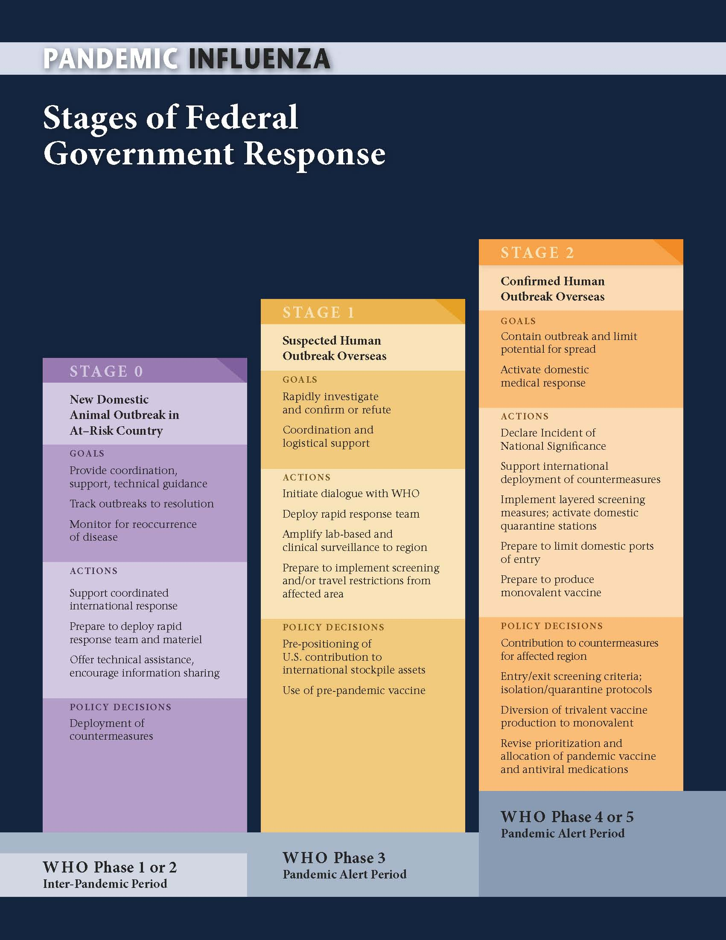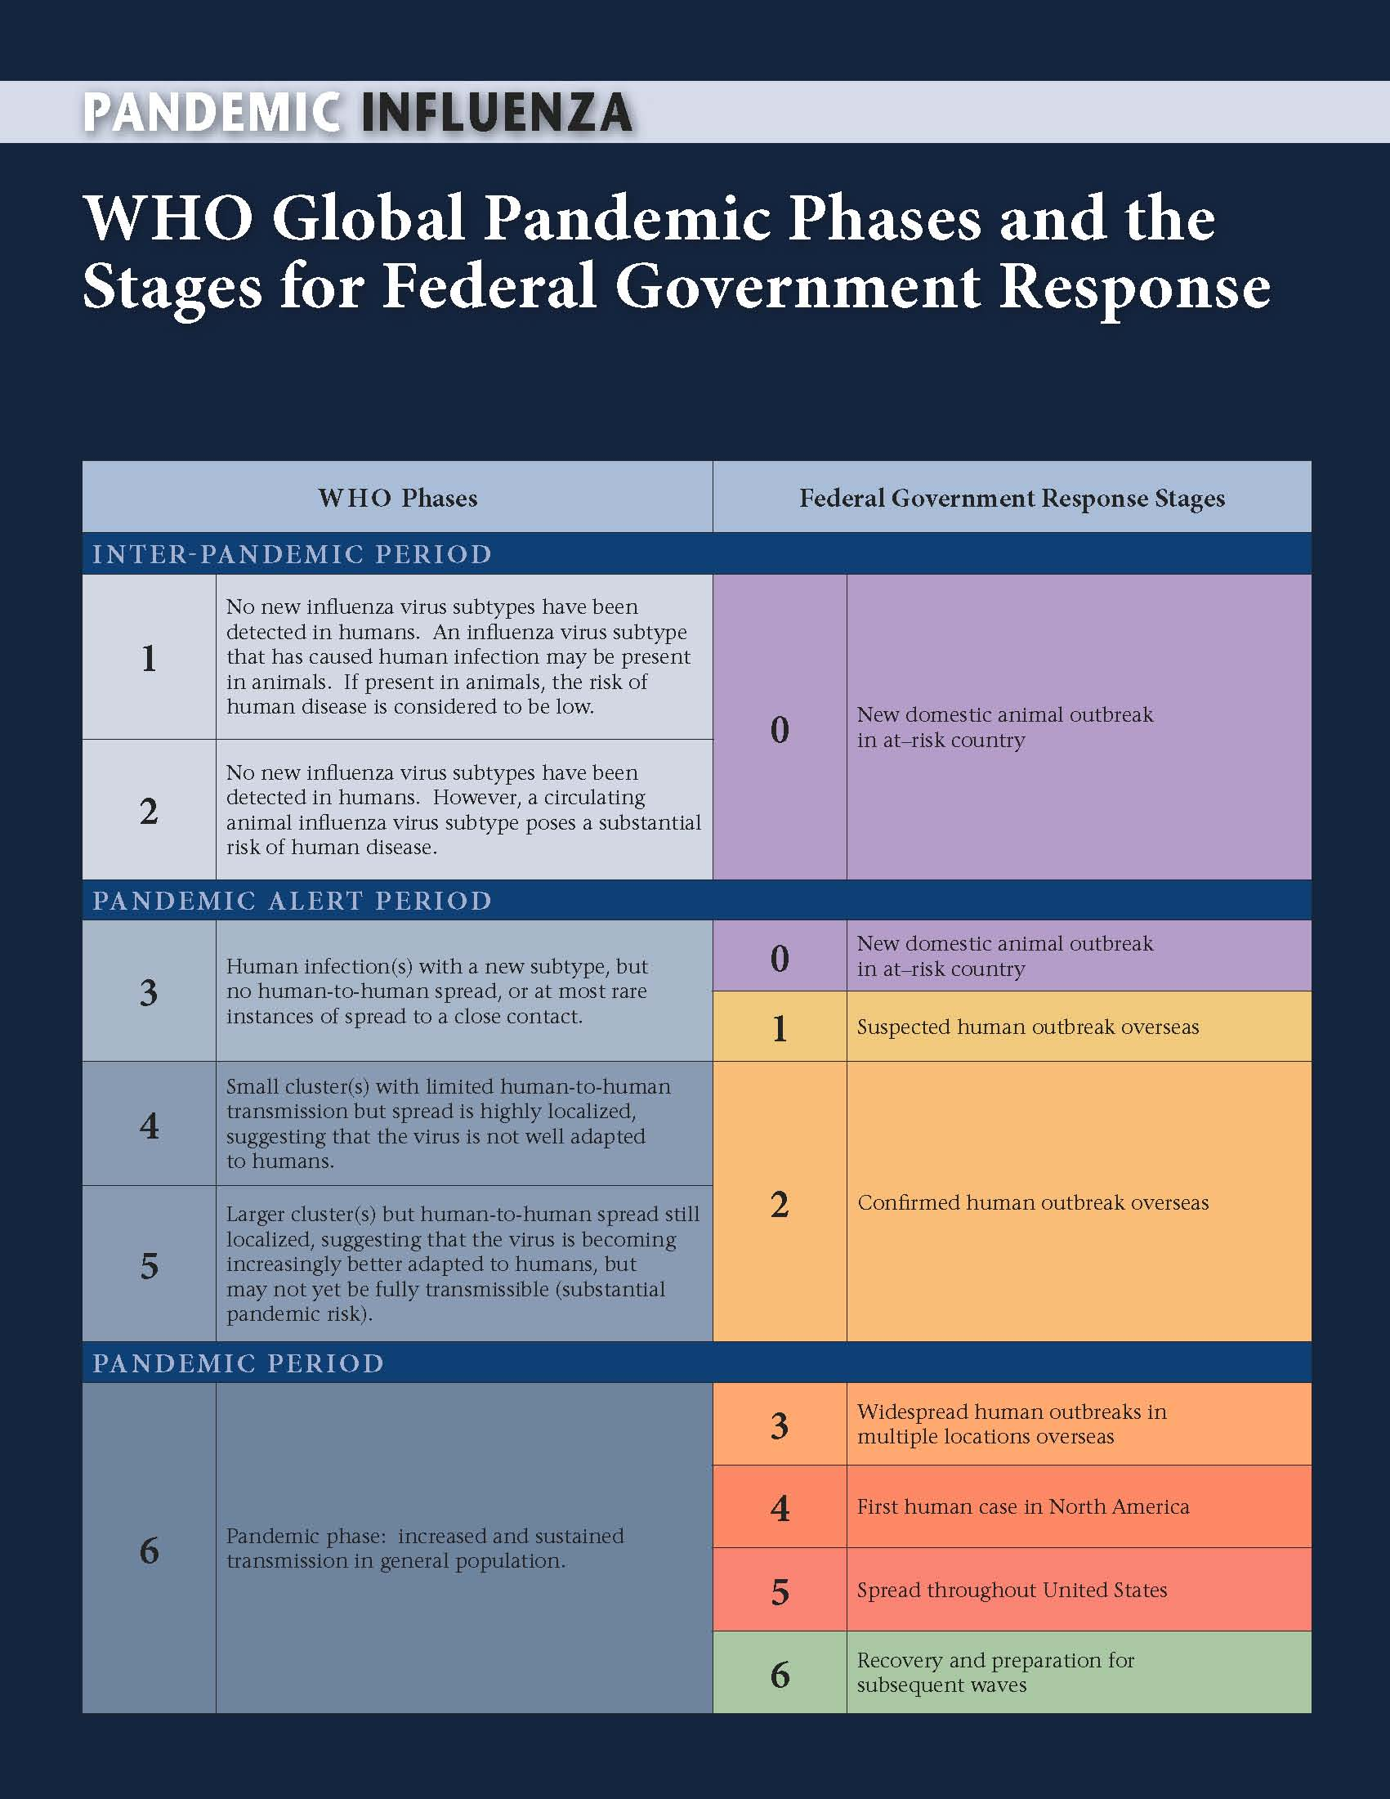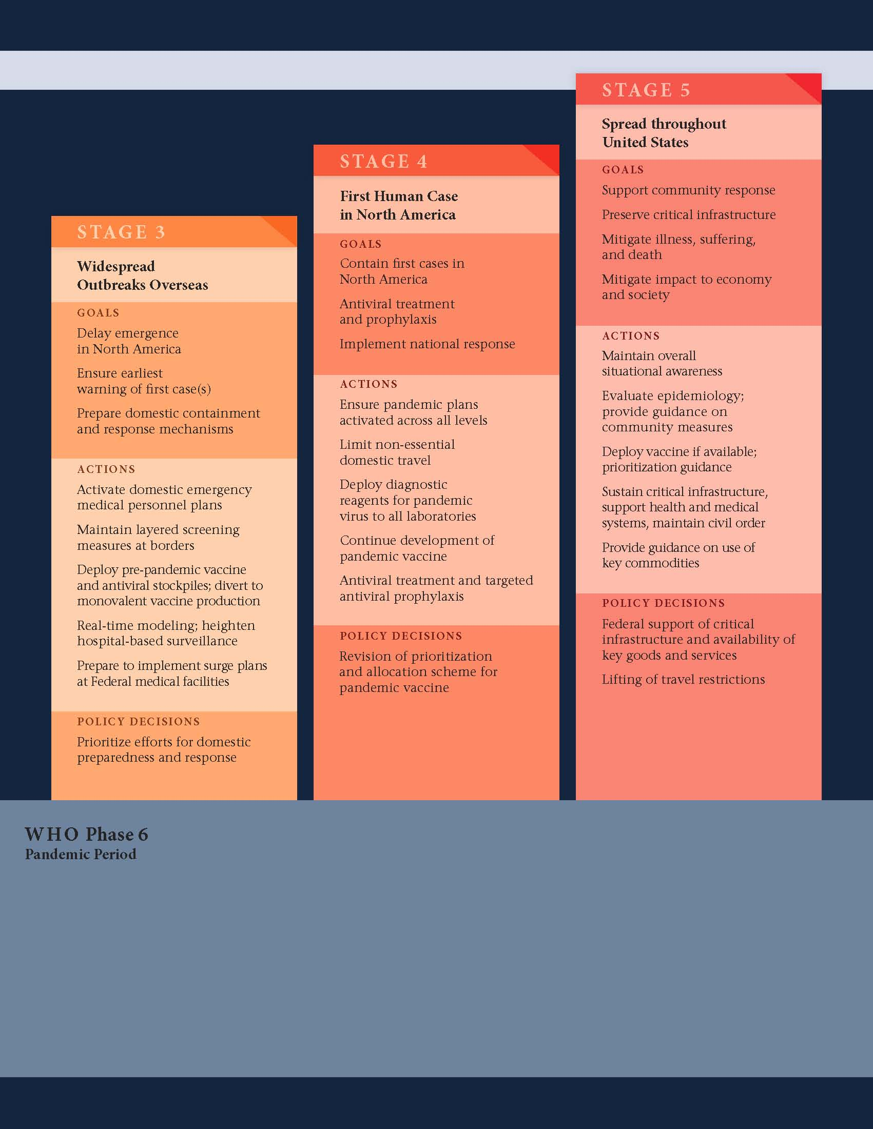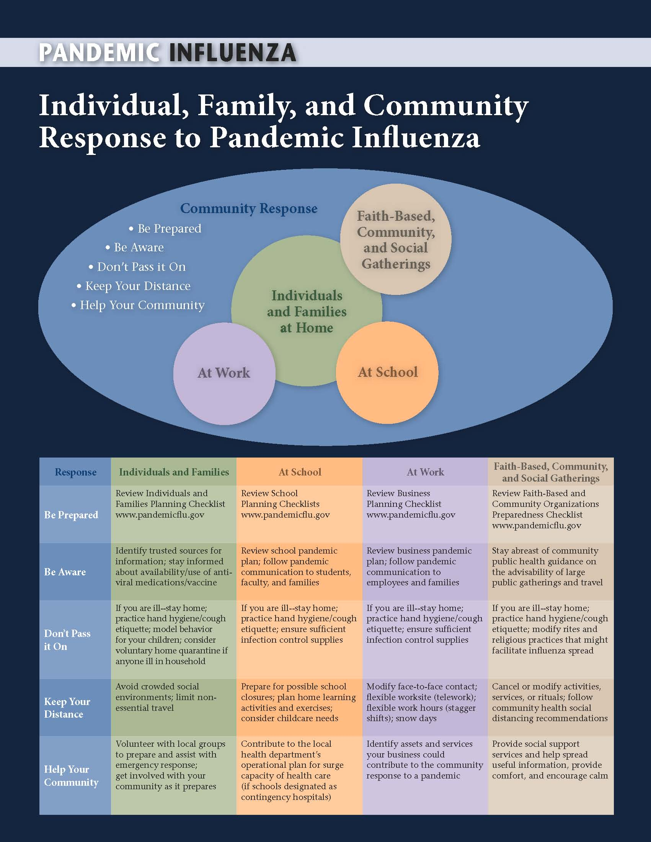

APPENDIX D - Considerations for business unit response plans and procedures

- Identify critical processes. Determine what cannot be done from home. Determine the minimum staff level required by each department for key processes.
- Identify key people in each area. Determine if they have to come in or if they can work remotely. Those who can work remote should sign up for broadband internet service from home if they don’t have it. Identify who needs a satellite phone, a blackberry, a laptop or a key fob. Oversee the tools being provided to the employee.
- Identify the alternate locations for work.
- Develop a cross-training plan and/or a plan for supplementing resources with the goal of 2-3 knowledgeable resources for the critical processes. Conduct a skills inventory to identify areas for development. Create a matrix of processes, information/data needed, skill needed, people and development needed.
- Identify key information that is on site that can’t be accessed through the network but would be needed to work from home. Plan for how the data would be made available.
- Set up a contact list for internal and external contacts; keep a copy on the network and provide key people with physical copies to keep at home
- Begin asking vendors if they have business continuity plans or pandemic response plans. Determine if products or services call for changes to the vendor contract.
- Succession planning is a must. Raise authorization limits for everyone in the chain of command.
- Encourage key people to practice ‘work at home’ on a regular basis
- Consider the need and response for sequestering, including accommodations and food
- Consider shift work
- Identify alternate work sites besides at home
- For critical operations remove human interaction points where possible
- Consider separating people across work locations
- Consider areas for communication breakdowns in critical processes
- Prepare a plan with response procedures for each of the five pandemic phases
- Once the plan is completed, evaluate its effectiveness:
  - Conduct a table top test to familiarize participants with roles, responsibilities and procedures
  - Conduct a walk-through test where actual responses are acted out in the context of a pandemic scenario

